https://www.nytimes.com/2023/02/03/briefing/why-eggs-cost-so-much.htmlNAME (first and last): ____________________________PERIOD: _______ DATE: ______________

**Pre Assessment: Data Analysis and Interpretation**

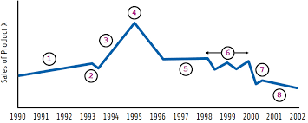

Examine the graph above. Remember a graph is data about an observable event (a phenomena).

Check ALL the **correct** answer (there are more than one):

* The line shows the change over time of a given phenomena that we have measured.
* The line represents data points.
* The x-axis shows time in seconds.
* We do not know what the phenomena is.

Do we know what this graph is telling us? Circle: YES NO

How would we find out what this graph is showing us? What would we look for? ___________________

For each number located on the graph, **describe** the pattern that you see. Identify the pattern by matching the following descriptions. There are more than one answer for each description.

| Description of data | Where we see this (record the number) |  | Description of data | Where we see this (record the number) |
| --- | --- | --- | --- | --- |
| Increases over time. |  |  | Increase is gradual. |  |
| Decreases over time. |  |  | Increase is rapid |  |
| Fluctuates. |  |  | Decrease is gradual |  |
| There is no change over time. |  |  | A rapid decrease, followed by a brief increase and further more gradual decrease. |  |
| A short term decrease |  |  | Decrease is rapid |  |
| The maximum |  |  |  |  |

Examine the graph below:

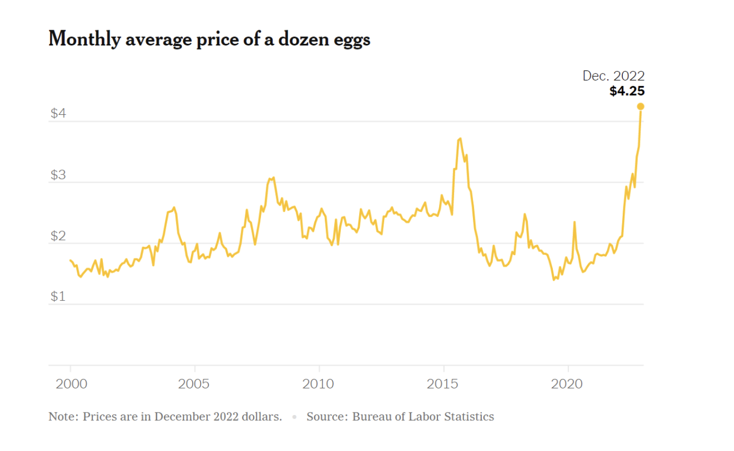

Graph from: <https://www.nytimes.com/2023/03/30/learning/whats-going-on-in-this-graph-april-5-2023.html>

Examine the graph above to complete the table below:

| **Phenomenon:**  (What is it that we are observing?) | What phenomena are you looking at? | Where is the data collected? (what country) | What is the time range of this data? (list start and end year). |
| --- | --- | --- | --- |
|  |  |  |
| **Variables:**  (What are we measuring?) | What data are we graphing? List the x-axis variable with units | What data are we graphing? List the y-axis variable with units | What does the y-variable mean? |
|  |  |  |
| **Source:** | Where am I getting the data to explain the patterns of this phenomenon? List the website or the source. | Mastery: How is the data collected? (how are scientists measuring this phenomenon?). | |
|  | Complete this portion on your actual assessment for mastery. | |
| **Accuracy:** How can I be sure this data is accurate and credible? Check what applies to the data/source materials you are using.  Sometimes the source can be identified by the website domain (.gov, .edu, .org). | * The data/source material comes from a scientific agency of the United States government. The website is **.gov** | * The data/source material comes from an educational resource. The website is **.edu** | * The data/source material comes from an organization with a scientific reputation with editors that fact check all publications. The website is **.org** |

**Analysis: Add notes on the graph above for the following:**

* Identify 2-3 time periods that show a significant change in the data. For example, think about where the data is increasing over time? And decreasing? Where is the data changing rapidly (steep slope) or gradually (gentle slope). Label these points on the graph.
* Identified and labeled the maximum data point and explained what that data point tells us.
* Use math to calculate the change in the y-axis variable between a time period of my choice and add this to the graph and rewrite the sentence below:

| Rewrite this sentence to show the change in time between two dates of your choice:  Between **(list dates)**, the y- variable, **(name this)** changed by |
| --- |

Extension:

Compare the graph above to this data shown on this graph, shown below. How are these two graphs related?

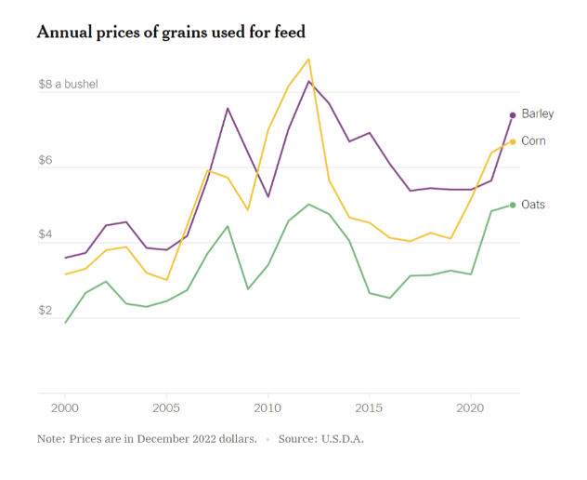

Graph from: <https://www.nytimes.com/2023/02/03/briefing/why-eggs-cost-so-much.html>

Share your thinking here: